**Apache**

1. sudo apt-get install apache2
2. sudo apt update
3. sudo vim /etc/apache2/ports.conf
4. set port to 8080 (use root privilege if needed to save - $Sudo su)



1. cd /var/www/
2. sudo mkdir apacheweb.com
3. cd apacheweb.com
4. sudo mkdir html
5. cd html
6. Create an Index file we want here
7. cd /etc/apache2/sites-available
8. sudo vim apacheweb.com.conf

Type the following and save

*<VirtualHost *:8080>*

*ServerAdmin admin@apacheweb.com*

*ServerName apacheweb.com*

*ServerAlias www.apacheweb.com*

*DocumentRoot /var/www/apacheweb.com/html*

*ErrorLog ${APACHE_LOG_DIR}/error.log*

*CustomLog ${APACHE_LOG_DIR}/access.log combined*

*</VirtualHost>*

1. sudo a2ensite apacheweb.com
2. sudo a2dissite 000-default.conf
3. sudo apache2ctl configtest
4. sudo systemctl reload apache2
5. sudo systemctl status apache2
6. sudo apt install net-tools
7. sudo netstat –tlpn

Apache 2 should run on port 8080

## Nginx

1. sudo apt install nginx
2. sudo apt update
3. cd /usr/share/nginx/html/
4. Create an Index file we want here
5. cd /etc/nginx/sites-available/
6. cp default original
   1. to create backup of original config file
7. sudo vim default
   1. change root to /usr/share/nginx/html/

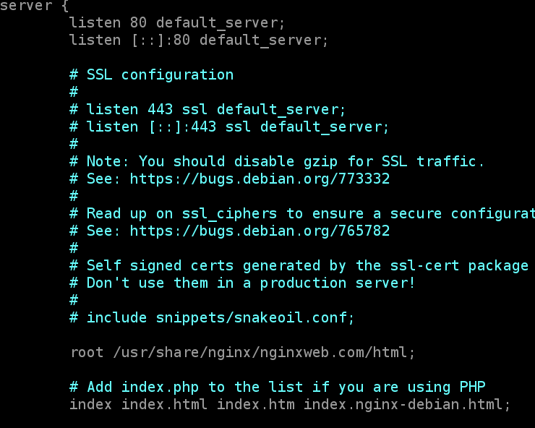

*(here I have used separate folder/domain for nginx website- it can be done directly without that too)

1. if we need reverse proxy add the following, save and exit

*}*

*server {*

*listen 80;*

*server_name apacheweb.com www.apacheweb.com;*

*location / {*

*proxy_pass http://localhost:8080;*

*proxy_set_header Host $host;*

*proxy_set_header X-Real-IP $remote_addr;*

*proxy_set_header X-Forwarded-For $proxy_add_x_forwarded_for;*

*proxy_set_header X-Forwarded-Proto $scheme;*

*}*

*}*

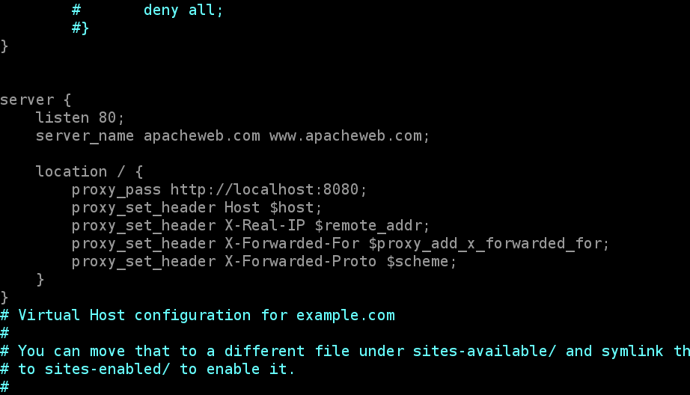

1. sudo rm /etc/nginx/sites-enabled/default
2. sudo ln –s /etc/nginx/sites-available/default /etc/nginx/sites-enabled/default
3. sudo nginx –t
4. sudo systemctl reload nginx
5. sudo systemctl status nginx
6. sudo netstat –tlpn

nginx should run on port 80